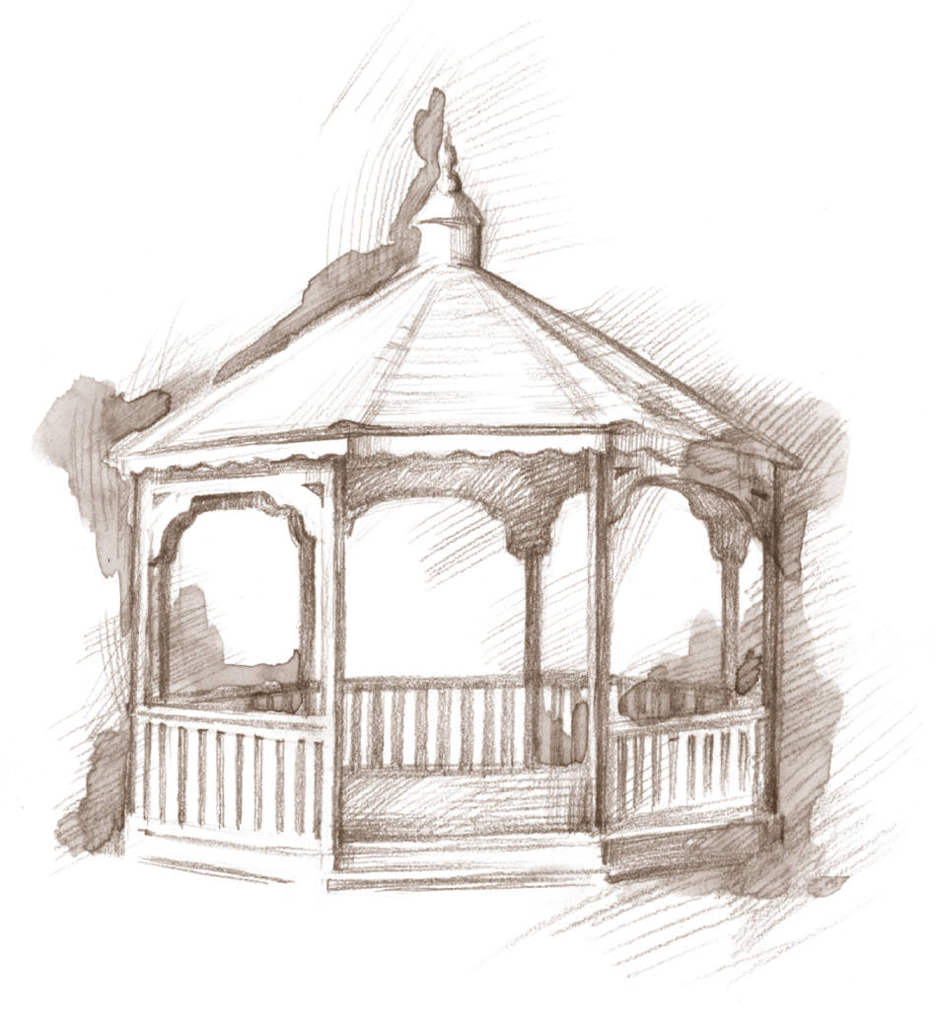
Town of Woodsboro, Texas
“The Friendly City”

113 Wood Ave. Phone 361-543-4505 Fax 361543-4187 Email waterclerk@woodsborotx.net

Utility Deposit Relinquishment
- I am requesting to relinquish my utility deposit of ______________ for
Amount of Deposit
______________________________________ account at ________________________________________.
Account Name Physical Address
**I understand that my utility bill must be paid in full before my account can be closed and my deposit relinquished to a new account.**

- My deposit of ____________ will be applied to _________________________
Amount of Deposit New Account Name

account at ________________________________________.
Physical Address
**I understand that if the relinquished deposit does not cover the current deposit fee, the amount of current deposit will be required for the new service account.**
**New account cannot be in service until customer service agreement is signed and deposit is applied or paid in full**

________________________________ ____________________
Signature Date

__________________________________________________ ___________________________
Water Clerk Effective Date

