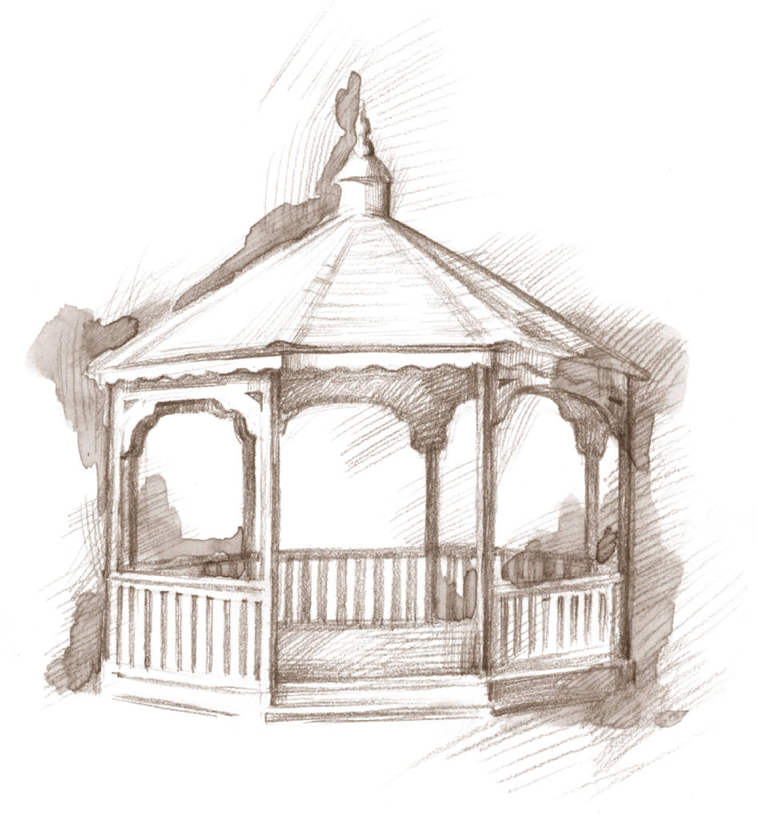
Town of Woodsboro, Texas
“The Friendly City”

Transfer of Utility Service

Name _________________________________________________ Driver’s License ______________________________
Property Owner/Renter/Occupant

I request to DISCONNECT service(s) at ____________________________________, effective ________________________.
Current Service Address Date

I request to RECONNECT service(s) at ____________________________________, effective ________________________.
New Service Address Date

Transfer Fee of $ ___________ Paid CASH / CHECK Deposit of $______________ on record

Please forward mail correspondence to:

Mailing Address: _____________________________________________________________________________________

WAIVER OF LIABILITY TO RECONNECT WATER & UTILTIY SERVICE

The policy of the Town of Woodsboro Utilities is that for service reconnection (whether or not a responsible party is on the premises), this waiver of liability form must be completed and signed by the property owner/renter/occupants and filed with the Town of Woodsboro’s Water Department Clerk. This waiver must be completed every time the service is reconnected.

RELEASE AND WAIVER OF LIABILITY: Property Owner/Renter/Occupant hereby RELEASES, WAIVES and DISCHARGES the Town of Woodsboro, its successors and assigns, and its officers, employees, agents and consultants, from all liability, loss, claims, damages, possible or actual causes of action, cost, attorneys’ fees, and other expenses arising from any actions, claims, arbitrations, demands or lawsuits that may otherwise accrue, including claims for or relating to damages, loss or injury to persons or property, in any way resulting from or related to the reconnection of the water service to this property, from any cause whatsoever.

By signing below, I am stating that I have read this agreement and understand the possible ramifications of allowing water service reconnection without a responsible party on the premises and that I am the owner/renter/occupant of the property listed above:

______________________________________________________ ___________________________________________
Property Owner/Renter/Occupant Name (Please Print ) Phone Number

______________________________________________________ ___________________________________________
Signature of Owner/Renter/ Occupant Date

