Town of Woodsboro, Texas
“The Friendly City”
Utility Payment Extension Request

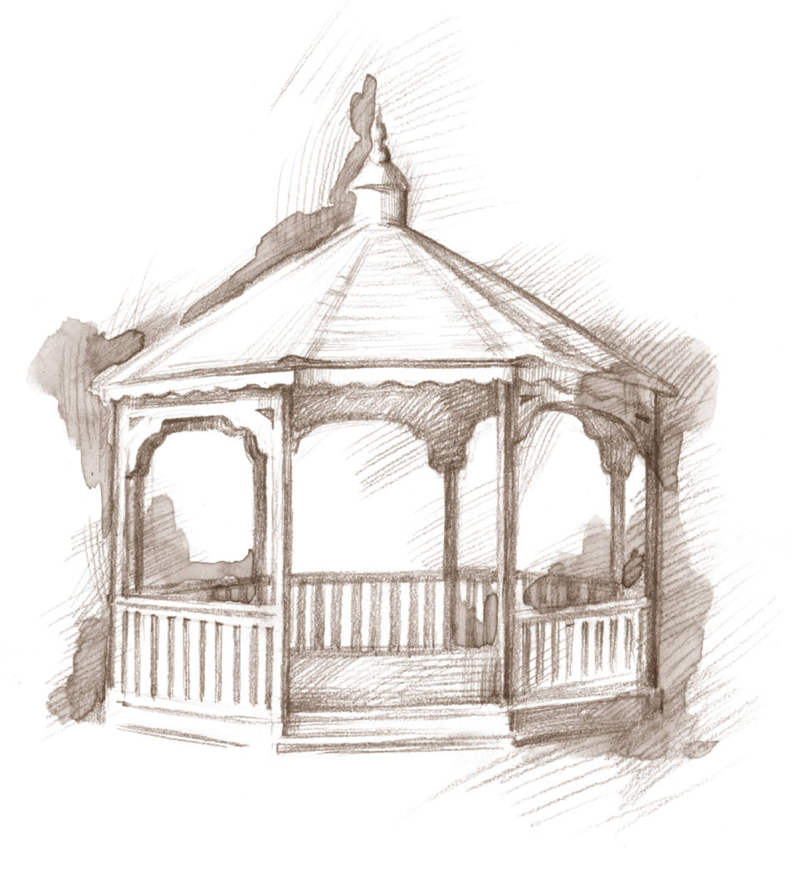

113 Wood Ave. Phone 361-543-4505 Fax 361-543-4187 Email waterclerk@woodsborotx.net

_______________________ _________________________________________
Date Name

_________________________________________ ________________________
Service Address Account #

Utility Bill Amount $ ____________________

Extension Fee $ _____________

Total Balance Due $ ____________________ Extension Due Date _________________________

***Failure to pay Balance due will result in Utility services being shut off. Total balance due in addition to $50 reconnect fee must be paid in full in order for services to be turned back on.***

I have read and agreed to these terms for extension of payment date for utility services.

_______________________________________________ _______________________________
Signature Date

_______________________________________________ _______________________________
Water Clerk Date

