Town of Woodsboro, Texas
“The Friendly City”
Utility Service Application

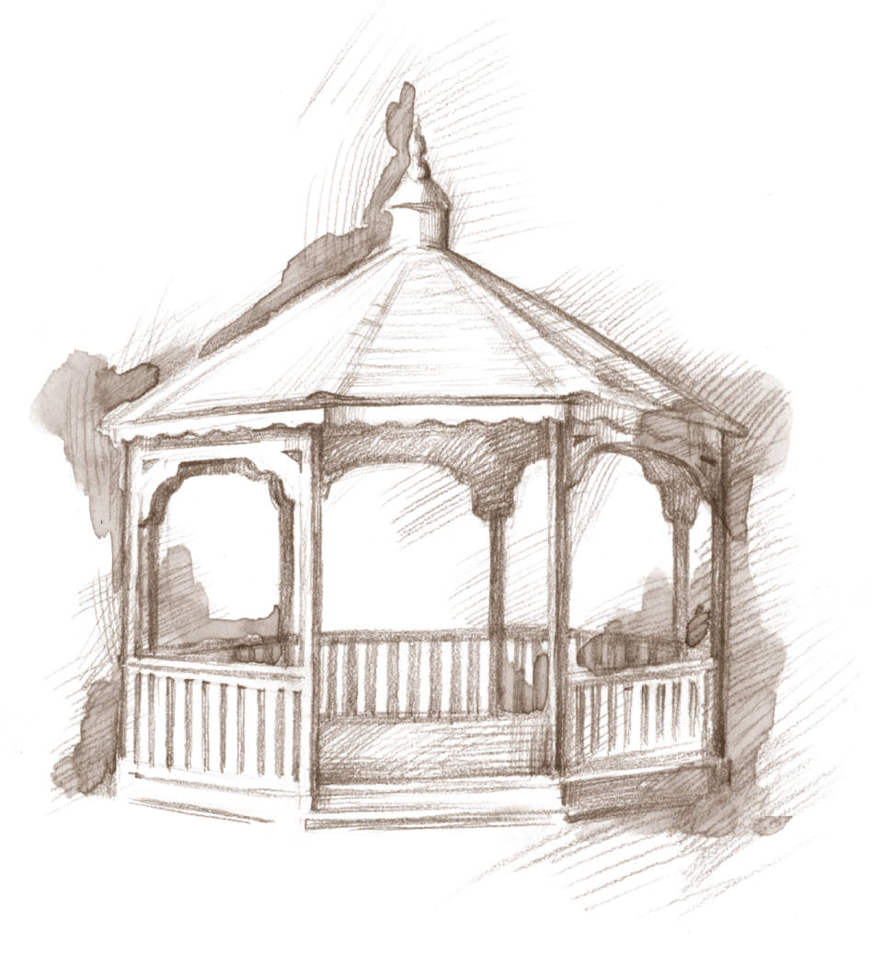

113 Wood Ave. Phone 361-543-4505 Fax 361-543-4187 Email waterclerk@woodsborotx.net

ACCOUNT NAME: List the name of the person or business (corporation) who owns or leases the premises where service will be used and who will be responsible for the account.

Name ____________________________________________________________________________________________
First Last

___________________________________________________________________________________________
Name of Business (if applicable)

NEW ACCOUNT INFORMATION
Please indicate the type and the ID number for one of the following forms of identification:
Social Security Texas Driver’s License Texas Identification Card
Resident Alien Other _______________________________

ID number _____________________________________________ (Must Have Copy on File)

ACCOUNT ADDRESS: Please enter the address where you want to receive service.

Location of Service___________________________________________________________________________________
Physical Address

MAILING ADDRESS: __________________________________________________________________________________

CONTACT INFORMATION: We may need to get in contact with you for informational or emergency purposes.

Phone_____________________________________________________________________________________________ Home Cell Work

E-mail Address______________________________________________________________________________________

Emergency Contact if you are not available: _______________________________________________________________
Name Phone

Office Use Only

Application Date _______________________________ Service Start Date _________________________________

Deposit Amount________________________________ Date Paid__________________________________________
Town of Woodsboro, Texas
“The Friendly City”
Utility Service Agreement

PURPOSE - The Town of Woodsboro is responsible for protecting the drinking water supply from contamination or pollution; which could result from improper private water distribution system construction or configuration. The purpose of this service agreement is to notify each customer of the plumbing restrictions, which are in place to provide this protection. The utility enforces these restrictions to ensure the public health and welfare. Each customer must sign this agreement before the Town of Woodsboro will begin service. In addition, when service to an existing connection has been suspended or terminated, the water system will not reestablish service unless it has a signed copy of this agreement.

RESTRICTIONS - The following unacceptable practices are prohibited by State regulations:
A. No direct connection between the public drinking water supply and a potential source of contamination is permitted. Potential sources of contamination shall be isolated from the public water system by an air-gap or an appropriate backflow prevention device.
B. No cross-connection between the public drinking water supply and a private water system is permitted. These potential threats to the public drinking water supply shall be eliminated at the service connection by the installation of an air-gap or a reduced pressure zone backflow prevention device.
C. No connection which allows water to be returned to the public drinking water supply is permitted.
D. No pipe or pipe fitting which contains more than 8.0% lead may be used for the installation or repair of plumbing at any connection which provides water for human use.
E. No solder or flux which contains more than 0.2% lead can be used for the installation or repair of plumbing at any connection which provides water for human use.

SERVICE AGREEMENT - The following are the terms of the service agreement between the Town of Woodsboro and the Customer.
A. The Town of Woodsboro will maintain a copy of this agreement as long as the Customer and/or the premises is connected to the Water System.
B. The Customer shall allow his property to be inspected for possible cross-connections and other potential contamination hazards. These inspections shall be conducted by the Town of Woodsboro or its designated agent prior to initiating new water service; when there is reason to believe that cross-connections or other potential contamination hazards exist; or after any major changes to the water distribution. The inspections shall be conducted during the Town of Woodsboro’s normal business hours.
C. The Town of Woodsboro shall notify the Customer in writing of any cross-connection or other potential contamination hazard which has been identified during the initial inspection or the periodic re-inspection.
D. The Customer shall immediately remove or isolate any potential cross-connections or other potential contamination hazards on his premises.
E. The Customer shall, at his expense, properly install, test, and maintain any backflow prevention device and customer cut-off valve required by the Town of Woodsboro. Copies of all testing maintenance records shall be provided to the Town of Woodsboro.
F. The customer hereby agrees to the following conditions:
- Pay water utility bill at ordinance rate within time allowed.
- Sign Termination of Service Agreement when moving or leaving premises.
- Install customer cut-off valve between meter and house. This valve is for customer use. State Law prohibits anyone other than utility providers to open or close water meters. Tampering with meters will result in a fine.
- No claim on the Town of Woodsboro for penalty or discount for failure on the part of the Water and Sewer to deliver the bill of charges which are to be paid in accordance with the town ordinance.
- Payment of all expenses and charges in accordance to said regulations and ordinances for default of service agreement.
G. All water shall be metered by meters furnished and installed by the Town of Woodsboro. The meter and wastewater connection is for the sole use of the customer and is to provide only one (1) dwelling or one (1) business. Any transfer of utility service from one property to another, to share, resell, or sub-meter to any other persons, dwellings, businesses or property is prohibited and will result in a fine.

ENFORCEMENT - If the Customer fails to comply with the terms of the Water Service Agreement, the Town of Woodsboro shall, at its option, either terminate service or properly install, test, and maintain an appropriate backflow prevention device or customer cut-off valve for the service connection. Any expenses associated with the enforcement of this agreement shall be billed to the Customer.

______________________________________ ____________________________________ _______________________
Name (please print) Signature Date

______________________________________________________ ___________________________________________
Mailing Address Phone

The following information is requested by the Federal Government in order to monitor compliance with Federal laws prohibiting discrimination against applicants seeking to participate in this program. You are not required to furnish this information, but we encourage you to do so. This information will not be used in evaluating your application or to discriminate against you in any way. However, if you choose to furnish it, we are required to note this race/national origin of individual applications on the basis of visual observation of surname.
-White, Not of Hispanic Origin -Asian or Pacific Islander -Hispanic -Male
-American Indian or Alaskan Native -Black, Not of Hispanic Origin -Other _________________ -Female

113 Wood Ave. Phone 361-543-4505 Fax 361-543-4187 Email waterclerk@woodsborotx.net

