Town of Woodsboro, Texas
“The Friendly City”

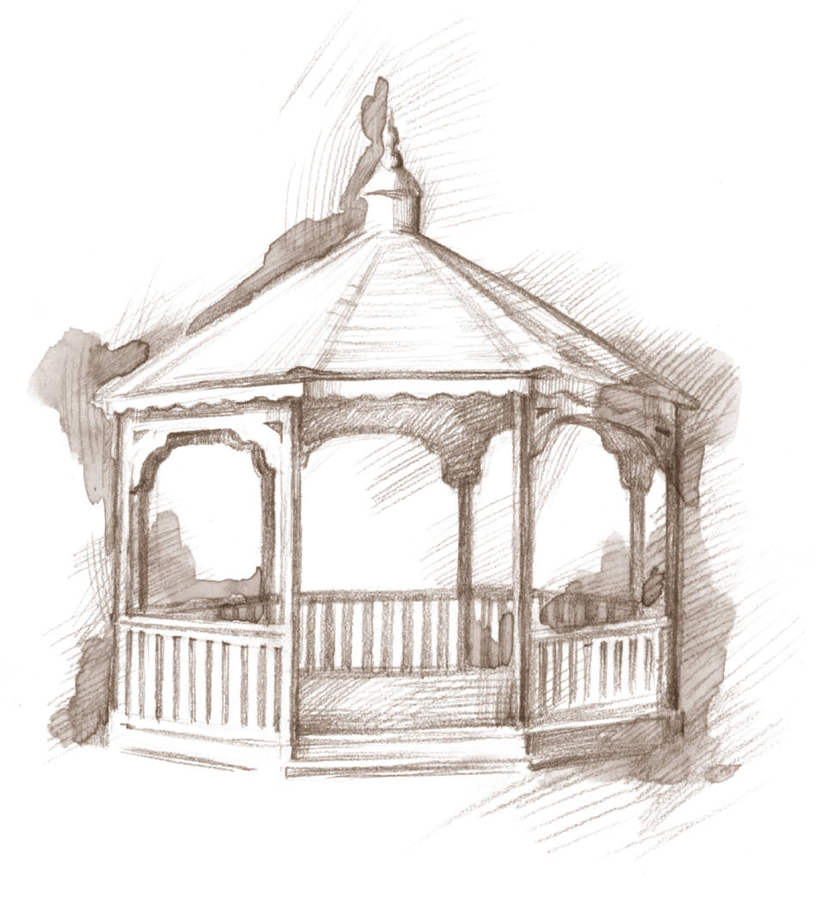

113 Wood Ave. Phone 361-543-4505 Fax 361-543-4187 Email waterclerk@woodsborotx.net

Termination of Utility Service

- Balance must be paid in full on date of service termination.
- Utilities deposit may be used to pay balance. Credit of balance will be issued after payment has been cleared.
- To reinstate utility services in the Town of Woodsboro, a deposit is due upon the request of service.
  - Customer must not have an outstanding balance with the Town of Woodsboro

Reason for termination of Utility Service

_______________________________________________________________________________________

_______________________________________________________________________________________

Customer Name ______________________________________ Date __________________________

Service Address __________________________________________________________________________

I have read this service policy agreement for Utility termination and accept the terms of this agreement with the Town of Woodsboro.

_________________________________________ _______________________________
Print Name Date

__________________________________________
Signature

______________________________________________ ___________________________________
Town of Woodsboro Clerk Date

