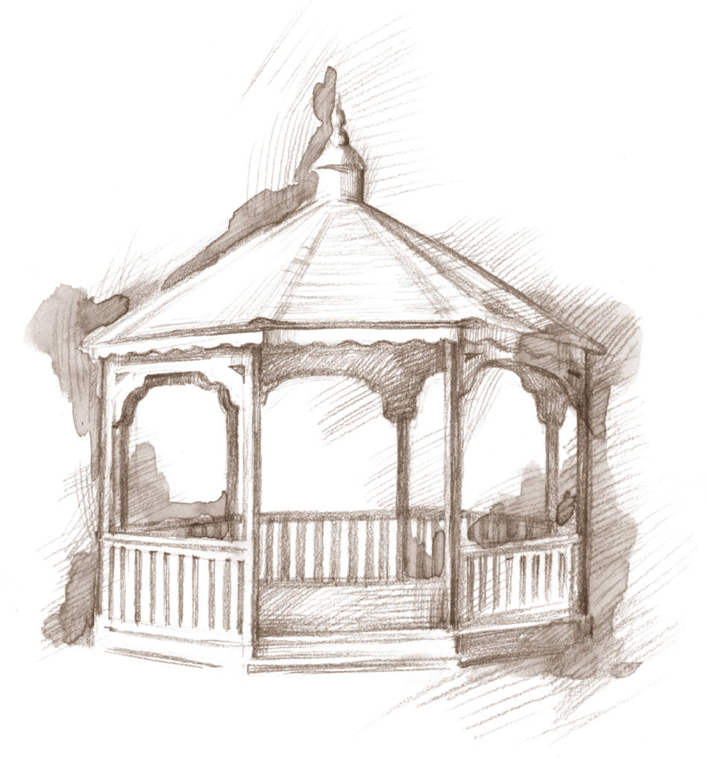
Town of Woodsboro, Texas
“The Friendly City”

113 Wood Ave. Phone 361-543-4505 Fax 361-543-4187 Email citysecretary@woodsborotx.net
Customer Service Agreement for Culvert Purchase & Installation
- The combined length of any one set of culverts may not exceed the maximum length of forty (40) feet.
- If more than forty (40) feet of culverts are desired, there must be an eight (8) foot opening between culverts.
- All culverts must be paid in full before installation.
- NO culverts will be installed EXCEPT by the Town of Woodsboro.
- Culvert maintenance and cleaning is the responsibility of customer/owner.
- Over time loss of filler may occur due to natural erosion and use of culvert. Customer will be responsible to purchase additional filler if necessary.

Customer Name ______________________________________ Date __________________________

Service Address __________________________________________________________________________

Culvert Size __________________________ Culvert Fee $______________

Additional filler may be purchased if requested and paid for in advance - Additional filler ________________________ Additional Fee $____________________________
Liability Release
I acknowledge that the Town of Woodsboro Public Works Director does not recommend placement of culvert, for the reason that:
Culvert placement over water service line to water meter.
- I understand that the Town of Woodsboro will not be responsible for any damages to culvert or replacement of materials if access to water service line is needed for repairs. All costs of any damages to utilities from use of culvert will be the sole responsibility of property owner.
Culvert size exceeds size of drainage ditch.
- I understand that the Town of Woodsboro will not be responsible for any damages to culvert, replacement of materials or flooding due to inadequate drainage flow. All costs of any damages due to inadequate drainage flow will be the sole responsibility of property owner.
Other ______________________________________________________________
I CERTIFY THAT I HAVE READ THIS DOCUMENT AND I FULLY UNDERSTAND ITS CONTENT. I AM AWARE THAT THIS IS A RELEASE OF LIABILITY AND A CONTRACT AND I SIGN IT OF MY OWN FREE WILL.

_____________________________________ ____________________
Customer Signature Date

______________________________________ _____________________
Customer approval after completion of work Date work completed

