**Customer Cut Off Installation**

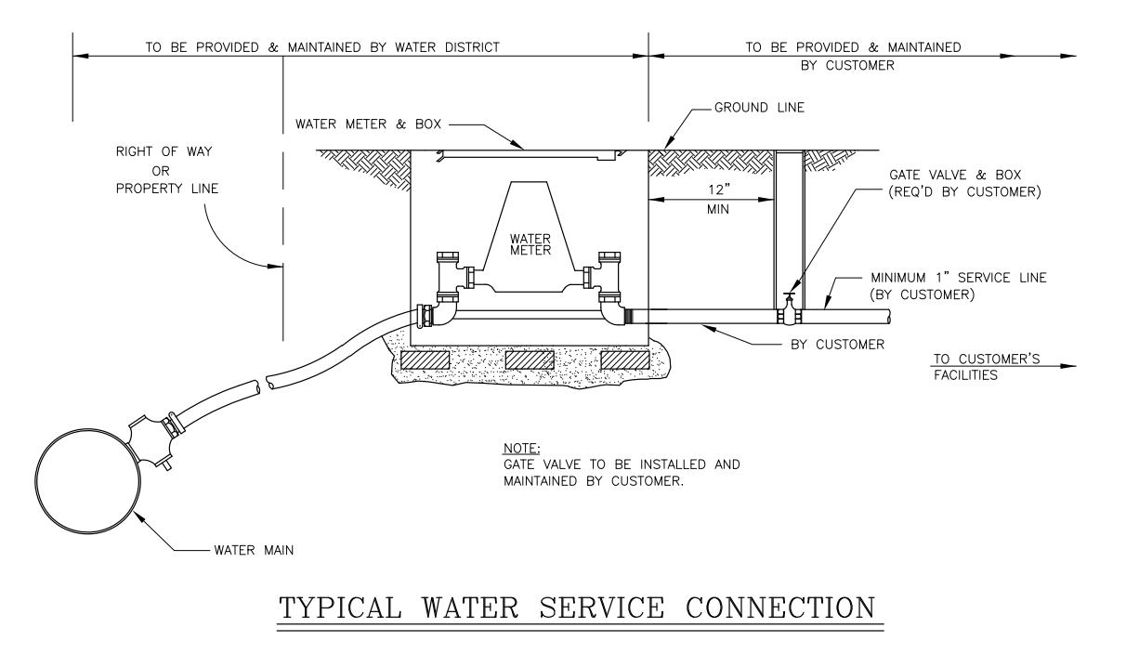

*City use only. Tampering will result in citation and/or fine.*

This cut off is for resident’s use. Installed to avoid service fee to open or close city’s water valve for emergencies or vacations. ***Tampering with city’s water valve will result in a citation and/or fine.***

